SCAVENGER HUNT PLANNING
Date: Saturday, October 5, 2 pm - 4:30 pm
Place: VCC playground (Currently, VCC has no rental confirmed yet so if we want to use inside facility, then we have to pay rental fee: the gym 50 CAD/hr; common room 40 CAD/hr and we can use washroom)
Participants:
- South Valour residents
- Board members
- Donors, sponsors, volunteers
Estimated number of participants: around 40
Theme: Community treasures
Join us for an exciting Scavenger Hunt adventure! Through fun games and riddles, we'll revisit the places in our play areas to explore the community treasures of our neighbourhood. It's the perfect chance to celebrate our community's strengths and plan for a brighter future together.
How to win: Participants will play games, solve riddles and do reflections to earn points and win the prizes.
Event flow:
2:00 pm - 2:15 pm: Welcome and registration, photo taking, everyone donating, reading instructions
2:15 pm - 4:00 pm: Riddles/Games time + Reflection
4:00 pm - 4:10 pm: Break time + Event board discuss on winners
4:10 pm - 4:20 pm: Announcing winners of raffles, games and riddles
4:20 pm: Tidy up

- ROLES AND DETAILS:
Guest sign-in and ballots:  - Welcome attendees and let guests sign up form: ScavengerHuntSignUpForm.docx  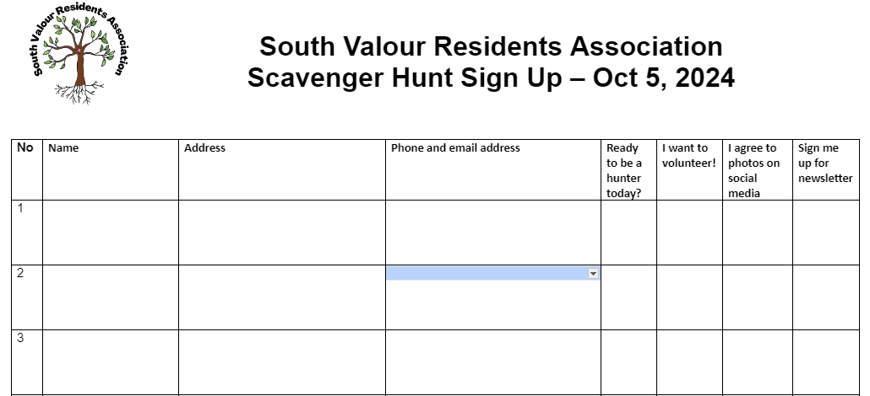  - For game participants, show and explain instruction leaflet (need to colour print 3 copies) and deliver riddle kits to players:  - There are 21 riddles to solve. Each riddle reveals a secret letter. Use the letters to spell three community treasures. For each community treasure you spell, you’ll get a ballot to win a special prize.  - Community treasures word find  - Participate in games and get 4 ballots. There are 4 games, each game to get ballot  - Participate in reflections on the places, get 1 ballot for each place  - Riddle kit: Scavenger Hunt Sheet, First Clue Card | Check on volunteers
Marketing communication:
ScavengerHunt-MarComm.docx
Flyer: ScavengerHuntFlyer
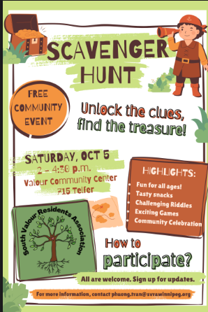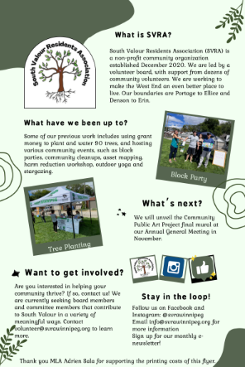
Poster:
Sponsors – donations:
- Volunteer will help contact our sponsors to ask for sponsorship.Donation Letter Scavenger Party.docx
- For business donors, a volunteer will go and talk to them. Some businesses to contact:
  - Slice’s Pizza
  - A Muse in Games
  - Co-op gas - might have to ask head office
  - Bowling - uptown
  - Goodies
  - Sleepy Owl
  - Wall Street Slice
  - Blady
  - Barn Hammer
- Budget: Kyle will give us 75 CAD for gift cards
  - Snack bags (chips, apple, juice): 40 bags
  - Water bottle: 3 bags
Board members to connect to buy prizes and get prize donations
Board member to buy items
Meet to prepare on Thursday, Oct 3 at 7 p.m.
Games tasks:
Before event date:
- Gather the game kits from VCC:
  - Ring toss
  - Bean bag toss
  - Backward soccer
  - Corn hole toss
- Prepare the game score sheet:
In the event:
- Collect the game kits at VCC stock and bring to the events. Should check with VCC about the date/time to come pick the game kits
- Display the game kits in the playground
- Explain the participants at the event how to play and monitor the playing progress and record the game results then pass the result to the score board to consolidate. (May do the trial if participants are not clear)
- Tidy up the game kits and return to VCC
Riddle tasks:
- Overall instruction: Participants will solve the riddles to get the letters and put them together into a community treasure (Omand’s Creek, Isaac Brock, Tree Canopy) then have a reflection upon completion
- Example of instruction here: Scavenger Hunt - Instruction.docx. Some participants may guess the results before they even reach all the hiding places. I will add in the instruction that they need to write their names in the check-in sheet put in the clue card.
- Scavenger Hunt Sheet:
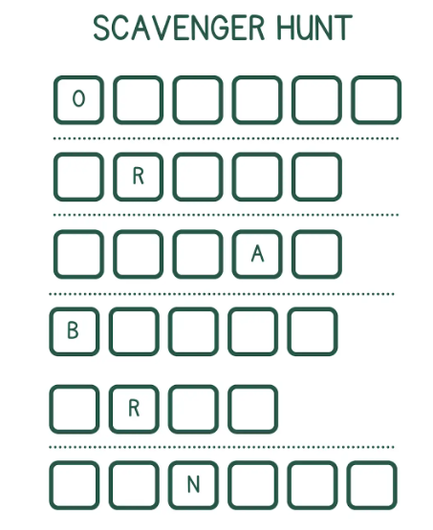

- Example Riddles and Locations: OMANDS CREEK
- Starting Point (Isaac Brock Door):
  - Riddle: ""To find the next clue, go where students learn, A place named for a Major General whose courage did burn. Seek the entrance where knowledge flows, The door to this letter, where curiosity grows.""
  - Letter: "O"
- Next clue (Valour Community Center-gym room):
  - Riddle: "For the next clue, where fitness is key, Go to the place of community and glee. Find the gym where athletes train, At this heart, your clue will remain."
  - Letter: "M"
Task list:
Before event date:
- Decide on the remaining riddle content. In order to do this, we need to decide the hiding places first, then utilize all your poetic skills and play spirits to write down the riddles. Phuong to figure out locations and write riddles.
- Prepare for the riddle kit (Instruction, Scavenger Hunt Sheet, Clue Card)
- Prepare the riddle registration sheet
- Print out the materials (should have an additional kit)
In the event date:
- Go to hiding places and put the Clue Cards (maybe in the morning and check again in the afternoon 1pm if any cards disappear)
- Show the riddle kit onto the registration table (Check again the day on sufficient materials printed out)
- Explain the riddle instruction to participants. (May think of doing an instruction map for those participants who are visual-orientated for better understanding of the instruction)
- Suggest the participants to do the reflection on the places they finish and record the reflection
- Record the results
- Pass the results to the score board to consolidate
Food service: Volunteer will email our MLA and city councillor to ask for sponsorship
- Wholesale: juice box, chip, apples/oranges to do kids snack bags
- Water
Task lists:
Before the event:
- Get the money and buy the necessary items as planned (food, bags, tape/strings to tie bags).
- Arrange food into bags (planning a food assembling party?)
In the event:
- Bring to the event site
- Deliver to participants
Set up:
Tables and chairs:
We will borrow tables from VCC for free. Need to carry the table out and return back.
- Welcome and Registration table
  - Turn into asset map feedback table
  - Mailing list
  - Volunteer list
- SVRA - 2 table, 2 chairs
  - Volunteers:
  - Bag sales
- Draw table/scavenger hunt
- Food table
- Table for artist who recently completed photo project with community members

Task lists:
Before the event:
- Contact VCC on borrowing the tables/chairs out (Done).
In the event:
- Bring the tables/chair out to the playground (Should coordinate with volunteer/team members)
- Return to VCC after the event (Should coordinate with volunteer/team members)
Volunteer:
Task list:
Before the event:
- Coordinate with members who is in charge of other event parts to see if they need a volunteer
- Check with the members to decide the roles that need volunteers, the proposed date and time of the volunteering activity and the number of volunteers that the event will need
- Inform me your need so I will pass to MarCom committee to send newsletters or social media post/flyer/posters
- Prepare the volunteer registration
- Email to volunteers on the event information
In the event:
- Welcome and do briefing or introduce to volunteers
- Keep checking on volunteers to see if they would need any help
- Send thank-you email after the event

Volunteer shifts are 12:30-2:30 or 2:30-4:30

Prizes: We ask businesses to sell and donate gift cards. We will buy 3 gift cards and ask for sponsorship of other 3 gift cards.
Make sure to put sponsors’ names on social media and sandwich board.Prepare for prize and sponsors. Prize/handing out ballots to enter for prizes Phuong ask Jolene for social tickets
Tote bag sales

