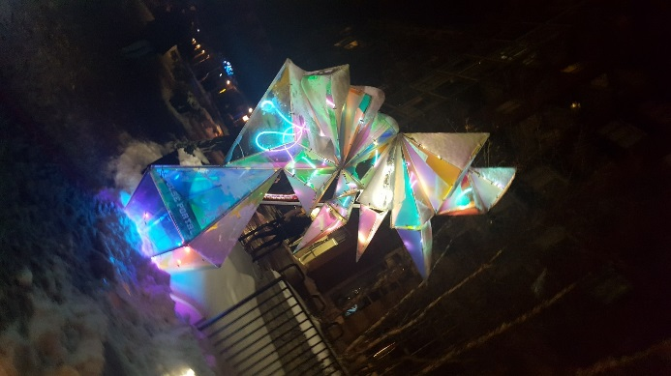
ELF Award winners: Lights, Camera, Action: ELF Project Presentations
For Presenters:
Please prepare to tell us about your work and progress in a presentation that takes 8-10 minutes (Please don’ t go over, so we have time for questions and discussion.)
You can prepare PowerPoint slides if you want a visual element.
Presenters are drawn from this and last year’s awards.
To ALL with interest in Experiential Learning:
Please come to 3C12 on Friday, November 16: 1-3
PROGRAM
Welcome from Jaqueline McLeod Rogers, Acting Associate Dean of ARTS
Greetings and congratulations from James Currie, VPA
- Shelley Tulloch and Erik Thrift:
“Instructional Support for Course-based Ethnographic Research”
- Judith Harris and Kevin Walby:
“Canadian Prison Education: Taking a Walls to Bridges Approach”
- Roland Bohr:
“Field Course: Material Culture in Northern Plains Indigenous History: ANPO Bison Ranch”
- Dawn Sutherland:
“DESTINATION IMAGINATION: in-school learning community”
- Dean Peachey:
Field Trip West Bank, Israel: “Quest for Peace and Justice”
- Nora Casson:
“Linked Undergrad Experience on Nutrients”
- German Avila Sakar:
“Urban Community Gardens”
- Julie Hyde and Karen Ridd:
“Mainstreaming Experiential Education through In-class activity Toolkits
- Shauna McKinnon:
“Youth United@WInnipeg: Indigenous and Non-Indigenous youth programming”
- Mirjana Roksandic:
Field Trip and Paleoanthropology in Serbia: “Salitrena Cave”
- Ryan Bullock:
“Land-based Learning on Indigenous Wellbeing and Connections”
- Ken Reimer:
“Designing Our Tomorrow Teams in Education”

